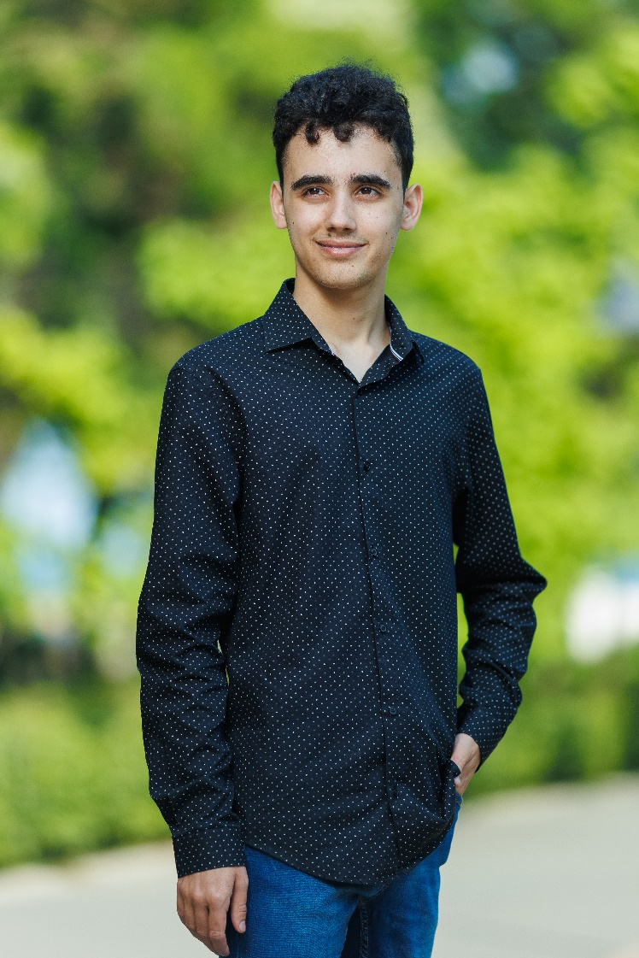

* [**My biggest solo project**](https://github.com/RafiBG/RomoTimer1)
* [**Group project 1**](https://github.com/SoniCrafterTB/TaskManager)
* [**Group project 2**](https://github.com/Simona03/ToDoListMVC)

***GitHub projects***

**More information about skills**

**Education**

* **Bulgarian**
* **English (Cambridge Certificate Level B1)**

***Skills***

Five years learning C# (OOP) , Python (Basics) , C++ (Tinkercad circuits) in Professional High School of Electrical Engineering and Electronics (City Burgas)

First year learning C++ (Basic)

I am currently studying Java (Basic) in Plovdiv University

***Languages***

* **Computer Science**
* **Programming in C#, C++,**

**Python, Java**

* **Databases (SQL tables)**
* **Operating systems**

**(Windows, Linux)**

* **Web programming**

**(HTML, CSS, PHP)**

* **Software development**

Plovdiv University "Paisiy Hilendarski" Mathematics and Informatics

I'm still learning (first year)

City Plovdiv

Professional High School of Electrical Engineering and Electronics "KONSTANTIN FOTINOV"

City Burgas

**CV - Curriculum vitae**

**Summary**

** 088 858 0860**

** rafichigarov@gmail.com Bulgaria Burgas**

Hi, I'm Rafi. I like to program and communicate with other people who like to do programming. I also like playing computer games and cycling with my friends. I will do my best to work together and achieve something magnificent.

**Rafi Tsigarov**